**CASE STUDY – 2**

Observation: ConnectWorld is a social networking platform trying to connect people around the world. It wants to provide users with a seamless experience for managing various data.

Challenge 1: Schema design.

Solution: As the requirement are dynamic in nature we can use NoSQL DB which allows schema less collections.

Challenge 2: Geospatial Data

Solution:

Challenge 3: Real-Time Updates:

Solution: We can do Real time updates by writing api call which we are integrating it in application code and deploying it in production. When ever the is update action is performed database will automatically get updated based on business logic.

Challenge 4: Security

Solution: In collection we can include on Key to represent Security level to maintain security.

Challenge 5: Scalability

Solution: To handle high volume of data NoSQL provide Horizontal scaling (Sharding) feature.

Output:

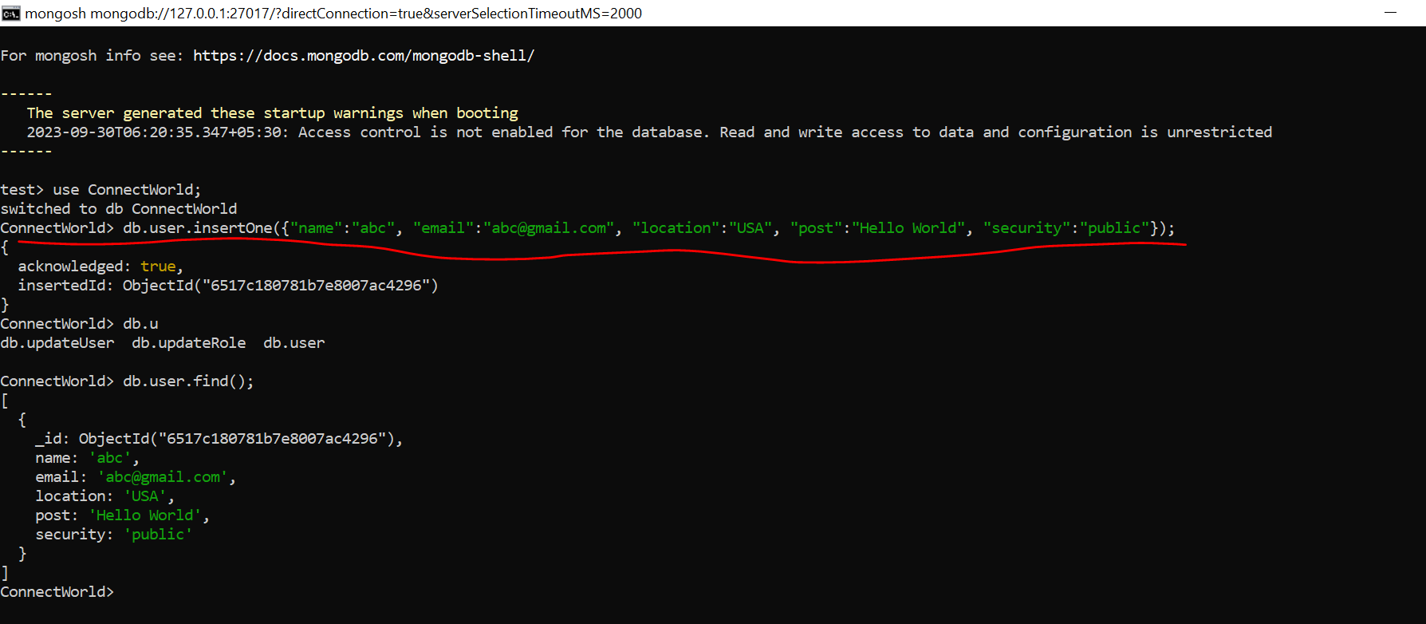

Above highlighted command is used to insert one document in a collection.

**Submitted by – Rohith Reddy**

**ID – vrddam@amazon.com**